**NORTH SOUTH UNIVERSITY**

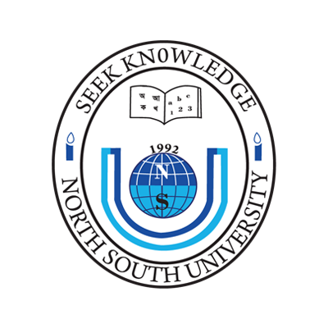

**CSE 499A** Section 21

Paperless Thesis Submission

**Instructor**DR. MD SHAHRIAR KARIM

**Due Date**27-th November 2019, Wednesday

Group: **Bright Sparks**

|  |  |
| --- | --- |
| SUMIYA NOORJAHAN **151 2065 642** | SHADAT HOSSAIN PABEL **161 2332 042** |
| FAREHA ALAMGIR **152 1464 642** | TANZIM AL DIN AHMED **162 1203 042** |
| FAHAD BIN BARI SHOVO **161 0162 042** |  |